Name: Yahia hamada Ibrahim

B/N:1

Sec:47

CODE:1036

Date:12/7/2021

Topic: Artificial intelligence

Git hub _link: https://github.com/yahia277/html-PROJEC-repository

Application Brief:

Artificial intelligence (AI) is an integration of computer science and physiology. Intelligence in simple language is the computational part of the ability to achieve goals in the world. Intelligence is the ability to think to imagine creating memorizing and understanding, recognizing patterns, making choices adapting to change and learn from experience. Artificial intelligence concerned with making computers behave like humans more human like fashion and in much less time than a human takes so is called as Artificial Intelligence (Poole and Goebel, 1998).

Computer assisted instruction has been in use for many years, bringing the power of the computer to bear on the educational process. Early CAI programs essentially imitated previously existing instructional materials. For example, a common CAI technique mirrors a method called programmed instruction. In a programmed instruction text, students read brief instructional material and then are presented with short questions to test their comprehension. Students turn to different pages of the book, depending on their answers to the questions, so that each student effectively programs a different path through the material based on individual comprehension abilities. The CAI technique based on programmed instruction is known as frame-based CAI. The effectiveness of frame based CAI program depends entirely on how well it is designed. Although many successful programs have been developed, frame based CAI programs use computers simply as electronic page turners.

. Advantages of Artificial Intelligence (AI) The benefits of artificial intelligence are incredible, what this area can offer us, is to evolve definitively and move on to the history of artificial robots. Following are the main advantages of Artificial Intelligence (AI). • Finished task faster than a human, • Stressful and complex work completed easily, • Difficult work done in short period, • Various functions can done at a time, • Success ratio is high, • Less errors in task and defects also, • More efficiency in short time, • Less space, less size, • Calculation of long term and complex situations, and • Discover unexplored things. i.e. outer space.

Adding AI techniques to CAI results in an effective, new instructional method called Intelligent Computer Assisted Instruction. The goal of ICAI is the development of instructional materials that actually analyze a student's performance in order to develop individualized tutoring strategies. The main components of an ICAI system are problem solving expertise, student model, and tutoring module. The problem solving expertise component of an ICAI program contains the knowledge that system tries to impart to the student. This expertise is represented with techniques similar to those used in the knowledge base of an expert system. In fact, this component can be thought of as a specialized expert system that contains expertise in domain of the ICAI program. The component of the program that selects the strategies for presenting tutorial information to students is called the tutoring module. A tutoring module generally incorporates natural language processing techniques to communicate at the level of each individual student.

Screenshots:

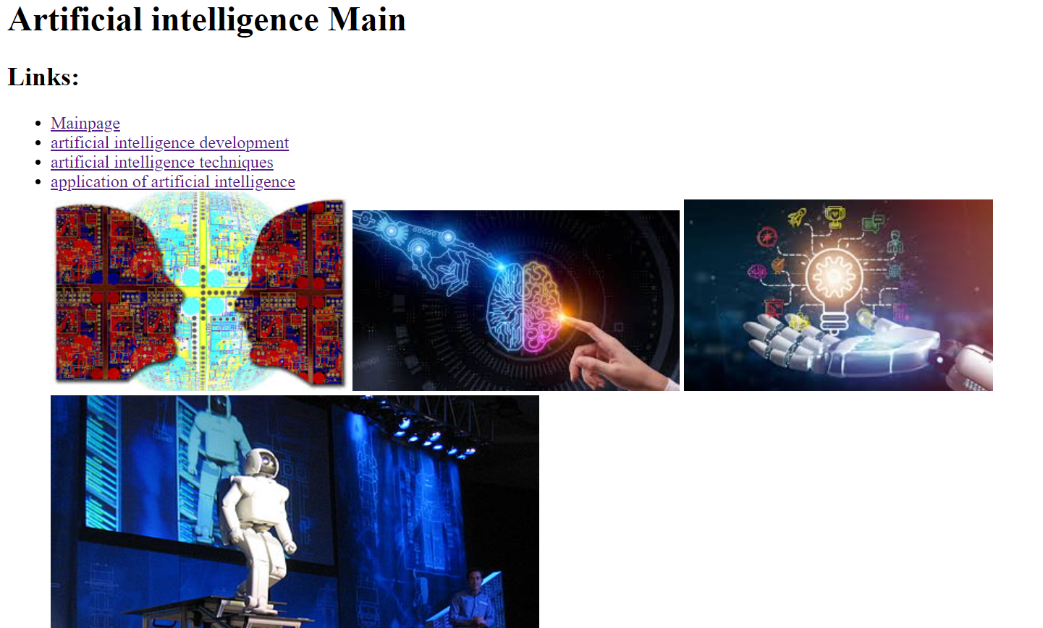

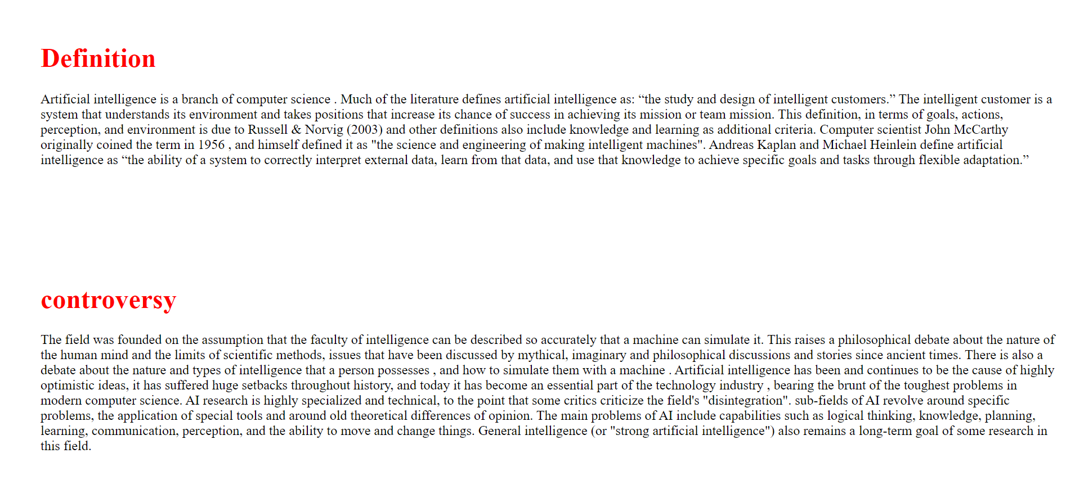

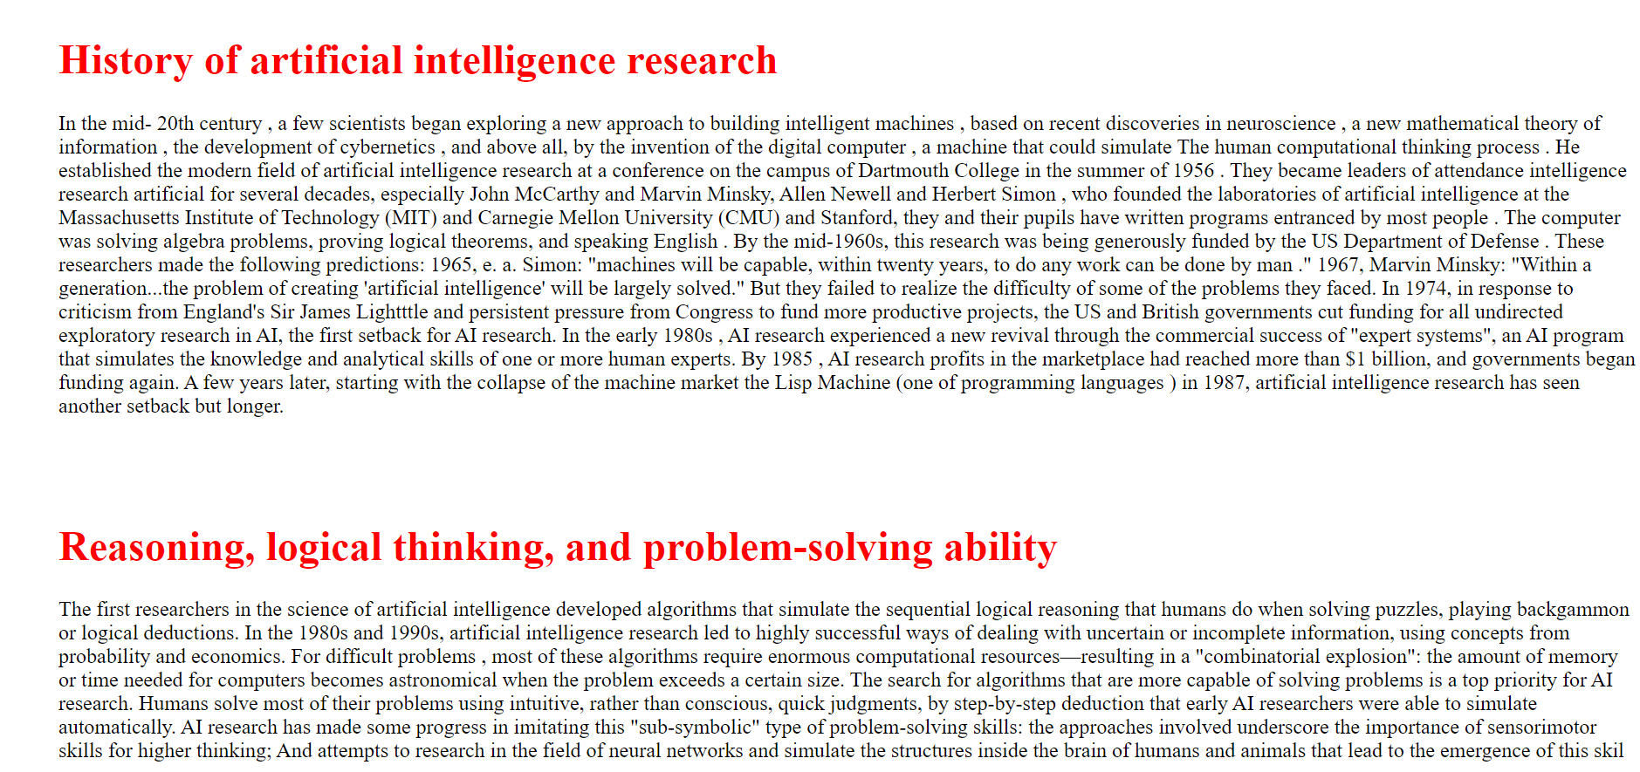

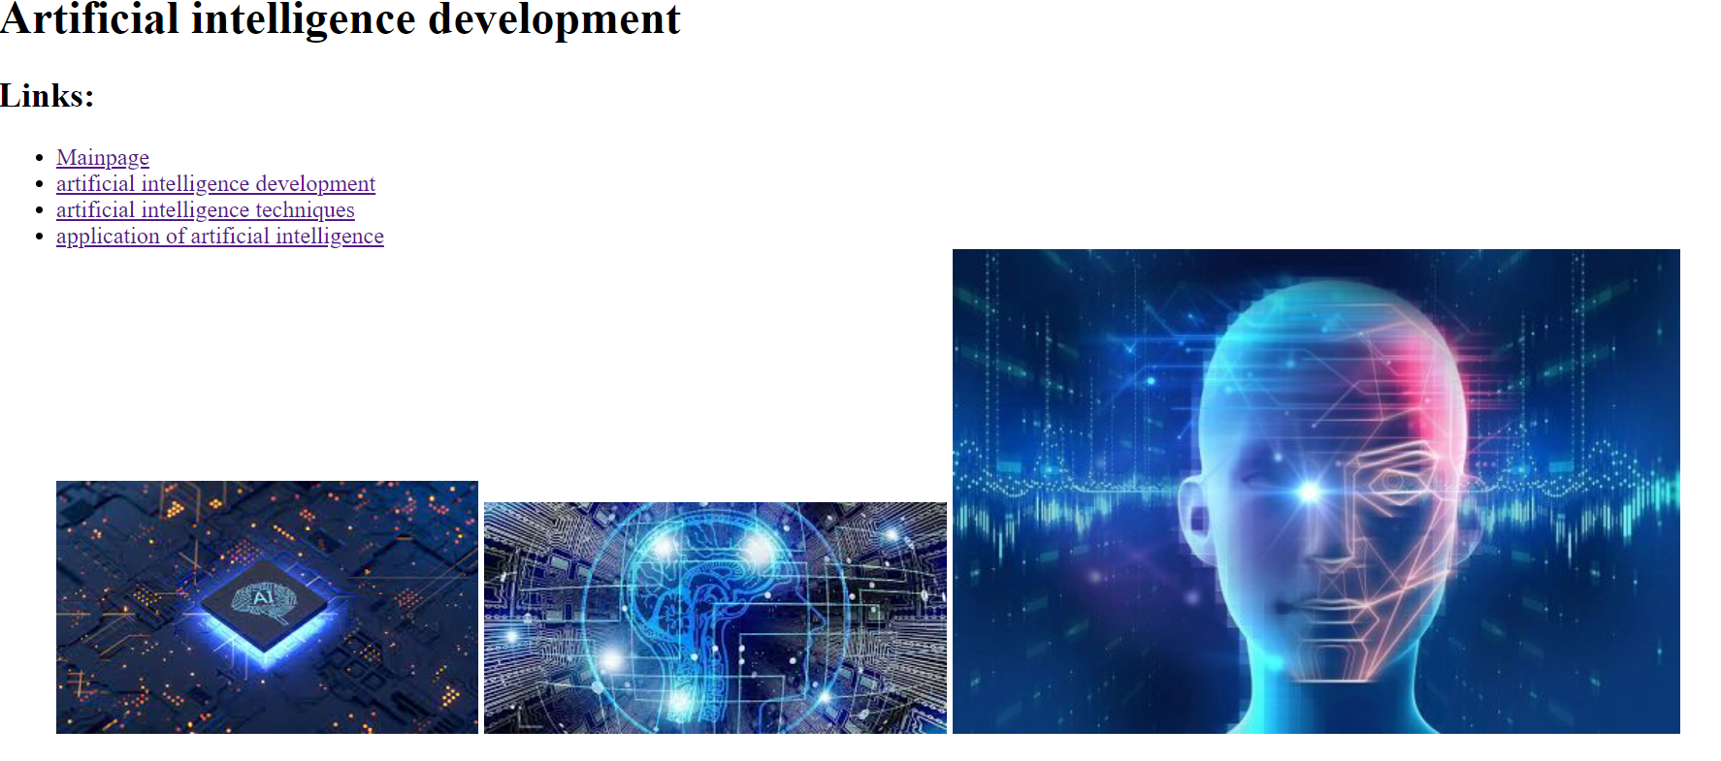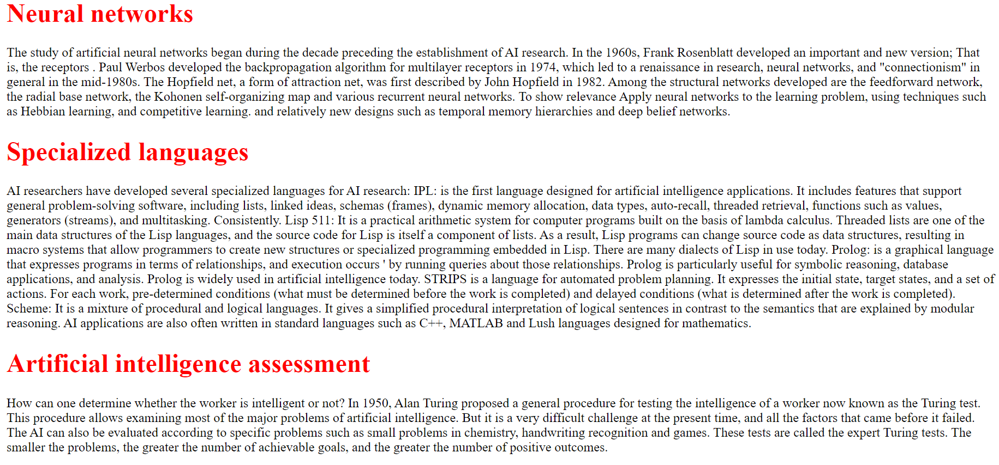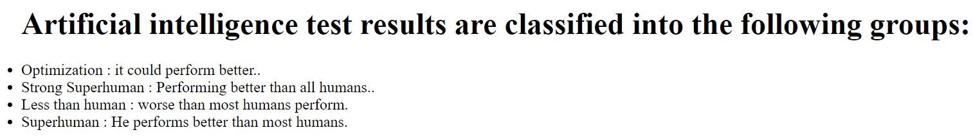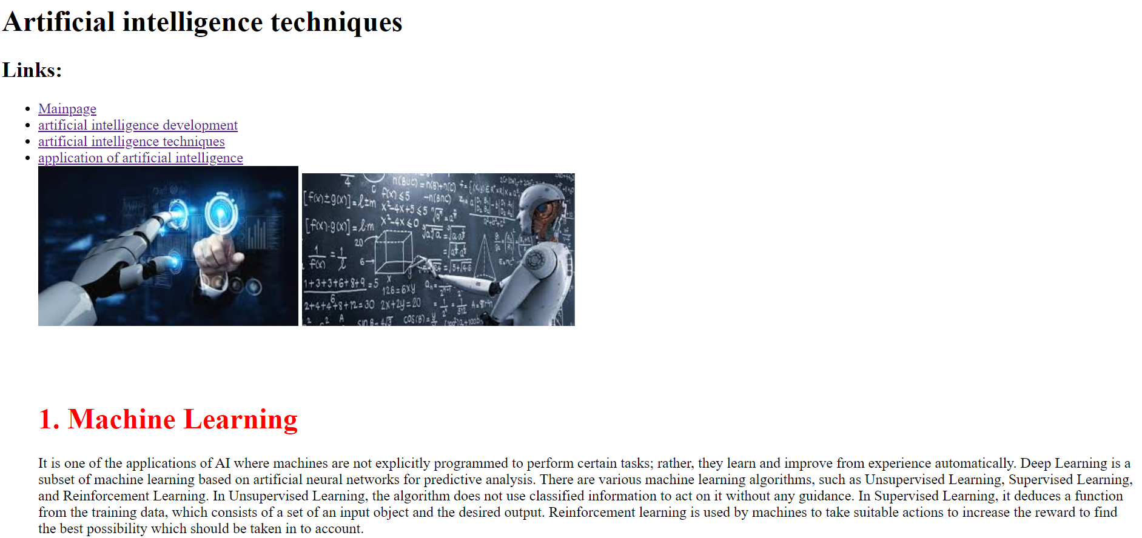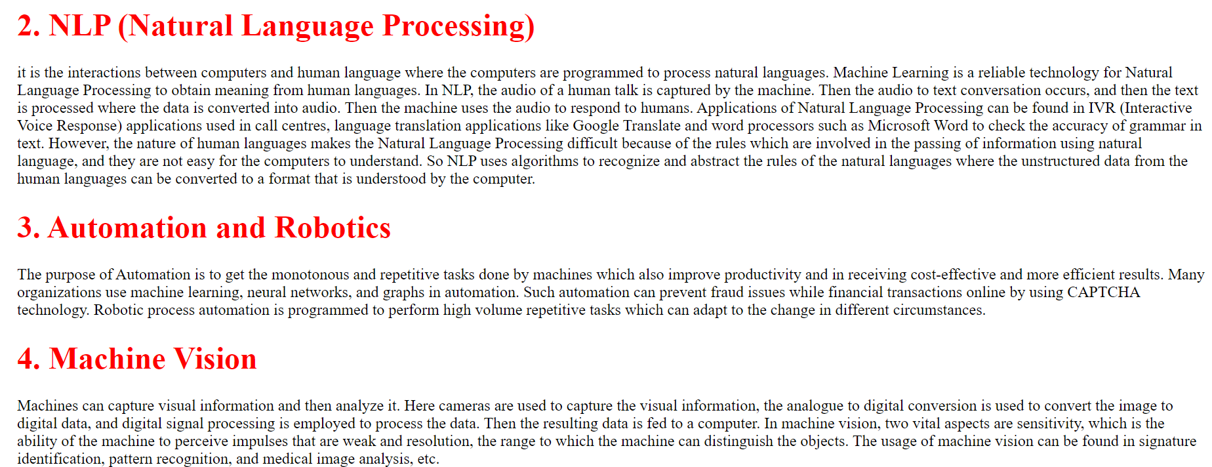 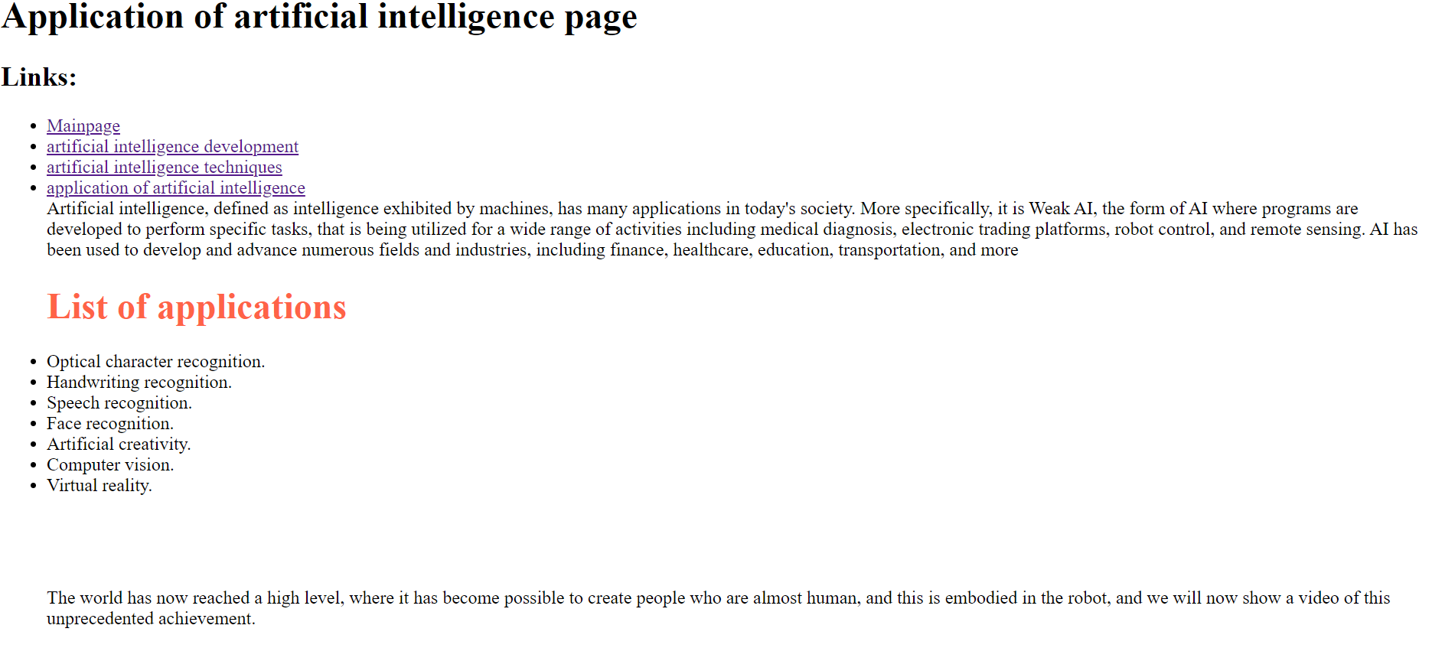Source code:

